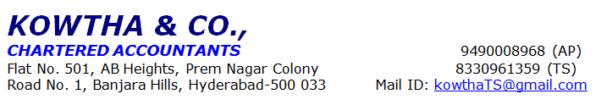
PD Meet - Self Employed Applicant
Prospect No. | DLMAH0HL-05250102314 |  |  |  |  |  |  |  | NOTE: Please tick/circle as applicable
Basic Details
Name | Mr. XXX
Marital Status | Single |  |  | Married |  |  |  |  | Divorced |  |  |  |  | Others
Educational Qualification | Below 10th |  |  | 10th Pass |  |  |  |  | 12th Pass |  |  |  |  | Diploma/ITI Certification |  |  | Graduate |  |  |  |  |  | PG/Professional Certification
Category | General |  |  | SC |  |  |  |  | ST |  |  |  |  | OBC |  |  | Others
Number of Dependents | Children |  |  | 02 |  |  |  |  | Adults |  |  |  |  | 04 |  |  | Others
Number of years in Current Residence | <=1 Year |  |  | 1-3 Years |  |  |  |  | 3-5 Years |  |  |  |  | >5 Years
Current residence house size | 1 RK |  |  | 1 BHK |  |  |  |  | 2 BHK |  |  |  |  | >2BHK
If <1= Year, then Previous Address | NA |  |  |  |  |  |  |  |  |  |  |  |  | Number of Years stayed at that Address |  |  | NA
Number of Years in Current City | <=3 Years |  |  | >3 Years
If <=3 Years in current city, then mention | Previous City |  |  | NA |  |  |  |  | Number of Years In that City |  |  |  |  | NA
 | Reason for Change |  |  | NA
Parents Staying with? | Self |  |  | Separate |  |  |  |  | Expired
If parents living separately, then mention | Residing City: |  |  |  |  |  |  |  | Residing location ownership status |  |  |  |  | Self-Owned / Parent-Owned / Rented
Assets and Investment Details
Assets Owned | Smartphone (Yes/No) |  |  | Washing Machine (Yes/No) |  |  |  |  | Car RC No:  (Yes/No) |  |  |  |  | Two-Wheeler  (Yes/No) |  |  | Auto/Cab  (Yes/No)
 | Computer/Laptop (Yes/No) |  |  | AC (Yes/No) |  |  |  |  | Fridge (Yes/No) |  |  |  |  | Induction (Yes/No)
Investments (Mention Amount if he owns or invest in any instrument) | . |  |  |  |  | Insurance (LIC) |  |  | Fixed Deposit |  |  |  |  | Chit Funds |  |  | Post Office Savings
 | Is Post Office savings monthly |  |  | Yes |  |  |  |  | No
 | Any Recurring Deposit |  |  | Yes |  |  |  |  | No
Do you consume Nicotine Products or Alcohol? | Yes |  |  | No
Employment Details
Name of Current Business Firm |  | M/s. AUTO DRIVER
Type of Business Firm |  | Proprietorship |  | Partnership |  |  |  |  | If Partnership, % shareholding
Date of commencement of Business |  | NA |  | Place of Incorporation |  |  |  |  | Address:XXXX
If above less than 3 years, provide Following details:-
Name of Previous Business | NA |  |  | Number of Years Worked there |  |  |  |  | NA |  |  |  |  | Reason for Change/Closing the Previous Business |  |  | NA
Total Work Experience | 11 Years
Official/Business Email-ID | -
Contact Number | XXX
Business Details
Type of Industry | Small Manufacturing Unit from Home/other premises |  |  | Trading |  |  |  |  | Services |  |  |  |  | Others, Please Specify:
Business Profile | Car Driver |  |  | Auto Garage/Two Wheeler Repairing shop |  |  |  |  | Auto Driver |  |  |  |  | Carpenter |  |  | Kirana Shop |  |  | Caterers
 | Coaching Classes |  |  | Computer/Mobile Repairing shop |  |  |  |  | Contractors of Diamond Polishing/Job work of Jewelry |  |  |  |  | Cyber Café |  |  | Fast Food Outlet |  |  | Labor Contractor
 | Milk |  |  | Pan Shop owner |  |  |  |  | Photography/studio |  |  |  |  | Spa & Hair Saloon |  |  | Tailor |  |  | Vegetable & Fruit Vendor
 | Others, Please Specify:
Business Premises ownership | Self-Owned |  |  | Family-Owned |  |  |  |  | Joint Ownership |  |  |  |  | Rented |  |  | NA
Area of office | <=250 Sq Ft |  |  | 251-400 Sq Feet |  |  |  |  | >400 Sq Ft |  |  |  |  | NA
Stocks/Assets Seen in Business Premises |  |  |  | Others (Please specify all major assets seen):
Locality of Business Premises | Residential |  |  | Corporate Hub/Office Space |  |  |  |  | Commercial |  |  |  |  | Industrial |  |  | Others
Annual Turnover | Rs.7,20,000/-
Net Profit Margin | 50.00% approx
Is Business seasonal? | Yes |  |  | No
Number of Employees | NA
Profile Description of employee/staff
Designation of Employee/Staff member | No of Employees in that role
-
No of Years for which Business Running in this Premises |  |  |  | If less than 3 years - Provide address details from where it was operating earlier
Popularity in Local Market | Average |  |  | Good |  |  |  |  |  |  |  | High
No of Competitors in Nearby Market
Final Product/Service of Business | Auto Services
Business started by | Self |  |  | Father / Other Family members |  |  |  |  | Mother
If Self Started, then source of initial Funds | Own Funding |  |  | Borrowed from Family |  |  |  |  | Loan |  |  |  |  | Others
Past Employment/Business Details
Employer/Business Name | Designation |  |  | From |  |  |  |  | To |  |  |  |  | Reason for Movement |  |  | Contact Person Name & Number
Business Income Computation (Monthly Basis)
Revenue | Amount (in Rs) |  |  |  | Expenditure |  |  |  |  | Amount (in Rs)
Sales | 60,000 |  |  |  | Wages |  |  |  |  | -
 |  |  |  |  | Diesel |  |  |  |  | 25,000
 |  |  |  |  | Maintenance & Repairs |  |  |  |  | 3,000
 |  |  |  |  | Other expenses |  |  |  |  | 2,000
Total Monthly Revenue (A) | 60,000 |  |  |  | Total Monthly Expenses(B) |  |  |  |  | 30,000
Net Monthly Profit (=A-B) | Rs.30,000/-
Other Monthly Income | NA
Rental Income | Cash Amount: |  |  | Cheque Amount:
Incentives/Perks | Cash Amount: |  |  | Cheque Amount:
Monthly Bonus | Cash Amount: |  |  | Cheque Amount:
Others, please specify source type |  |  |  | Monthly Income |  |  |  |  | Cash Amount:  Rs. |  |  |  |  | Cheque Amount:
Existing or Past Loan Details
Loan Type | Lending Institution Name |  |  |  |  |  |  |  |  |  | Loan Amount (In Rs.) |  |  |  |  | Tenure remaining |  |  | EMI
-
Loan Details
Purpose Of Loan | Flat Purchase |  |  | House Purchase |  |  |  |  | Plot Purchase |  |  |  |  | Construction of Residential House Property
 | Improvement/Extension |  |  | Balance Transfer |  |  |  |  | Plot + Construction |  |  |  |  | Hand Loan Clearance
Minimum Loan Amount Required | Rs.10,00,000/-
Tenure Required | -
Monthly Household Expenses | -
Comfortable EMI | -
Status of Property to be Purchased | Ready |  |  | Under Construction |  |  |  |  | Construction Yet to Start
Usage of Property after Purchase | Self-Occupancy |  |  | Investment |  |  |  |  | Others |  |  |  |  | Renting Purpose
Cost and Funds Information(Loan Details)
Funds Required | Rs.10,00,000/- |  |  |  |  |  |  |  | Source of Own Funds (OCR)
Purchase Cost |  |  |  |  |  |  |  |  | Savings
Construction Estimate |  |  |  |  |  |  |  |  | Family/Friends
Registration/Stamp Duty Charges |  |  |  |  |  |  |  |  | Other Loan Taken
Other expenses |  |  |  |  |  |  |  |  | Total Amount Spent (Total of all the above)
Total Transaction Cost (Total of all the above cost) | Rs.10,00,000/- |  |  |  |  |  |  |  | Mode of Payment to Seller |  |  |  |  | Cash Amount: |  |  | Cheque Amount:
Other Family Member Details
Name | Relationship |  |  |  | Age |  | Employment Type |  |  |  |  |  | Educational Qualification(Also mention if Govt. or Private institution) |  |  |  | Contact No. |  |  | Staying with Applicant
XX | Spouse |  |  |  | 35 |  | House wife |  |  |  |  |  | - |  |  |  | - |  |  | Yes/No
 | Daughter |  |  |  | 13 |  | Student |  |  |  |  |  | 9th class |  |  |  | - |  |  | Yes/No
 | Son |  |  |  | 11 |  | Student |  |  |  |  |  | 5th class |  |  |  | - |  |  | Yes/No
References (Business Parties)
Reference 1 | Photo with Applicant |  |  |  |  |  |  |  | Reference 2 |  |  |  |  | Photo with Applicant
Name | XXX |  |  |  |  |  |  |  | Name |  |  |  |  | XXX
Address |  |  |  |  |  |  |  |  | Address
Relationship |  |  |  |  |  |  |  |  | Relationship
Contact Number |  |  |  |  |  |  |  |  | Contact Number
Email Address |  |  |  |  |  |  |  |  | Email Address
No of Years known the Applicant |  |  |  |  |  |  |  |  | No of Years known the Applicant
Business Firm Check (From Neighbor/ Independent checking/ From existing customer)
Reference 1 |  |  | Business Card Collected |  |  |  |  | Reference 2 |  |  |  |  |  | Business Card Collected
Name of the Person |  |  | XXX |  |  |  |  | Name of the Person |  |  |  |  |  | XXX
Name of Business Firm |  |  |  |  |  |  |  | Name of Business Firm
Address |  |  |  |  |  |  |  | Address
Number of years known the firm |  |  |  |  |  |  |  | Number of years known the firm
Contact Number |  |  |  |  |  |  |  | Contact Number
Feedback about the Applicant/Firm |  |  | Positive/Neutral/Negative |  |  |  |  | Feedback about the Applicant/Firm |  |  |  |  |  | Positive/Neutral/Negative
To be Filled by PD Officer
Brief Comments/Observation of the case | Initiated Address XX  Visited Address XX  Residential Address XXX  - Applicant is native of XXX and aged 44 years old and under graduate.  - In the year 2014, applicant running Passenger auto services with the name of M/s. XXXX.  - Nature of Business is Auto Services to General Passengers.  - Applicant is auto driver and he has 11 years of experience.  - He has own passenger auto to these Transport services.  - He does single routes from XXXX to surrounding areas daily services.  - On average he does 8-10 rounds trip per day.  - His vehicle capacity is around 3+4 persons and he charges Rs. 20/- per head.  - He runs this vehicle for 26 days in a month.  - He has own Auto for these transport services and vehicle number is AP22Y5173.  - Neighbor check done we got positive feedback about the Applicant.  - The Status of the case is Positive.  Other Observations:  - Good level of business activity seen during visit  - Vehicle seen during seen.  - Submitted Vehicle RC Copy  - Submitted Driving License  Concerns:  - No purchases bills provided.  - No MSME certificate provided  - No Labor license provided  - No bank statement provided  - No power bill provided  - No business name board seen  Status : POSITIVE
Name of PD Officer | Mr. XXX
Date of Discussion | 11-04-2025 |  |  | Signature of the PD Officer |  |  |  |  | XXX
Disclaimer Clause:
This report (including any attachments) has been prepared based on verbal information provided by the person contacted. NIWAS HOME FINANCE PRIVATE LIMITED will be solely responsible for any actions taken on this report and any liabilities directly or indirectly accruing from such actions. M/s. KOWTHA & CO will not be held liable in any case.
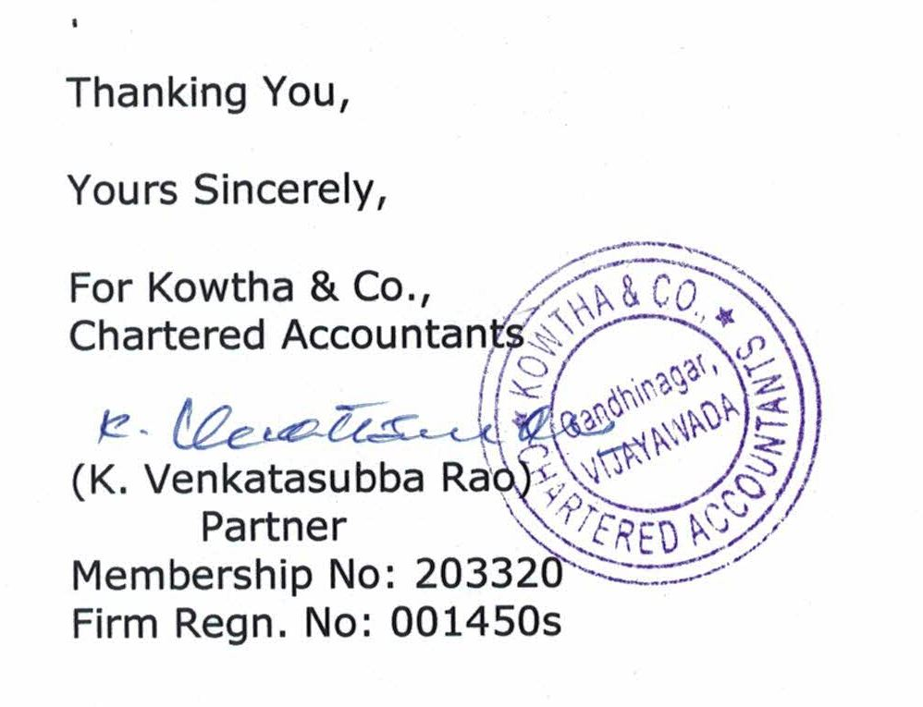

Photos:

